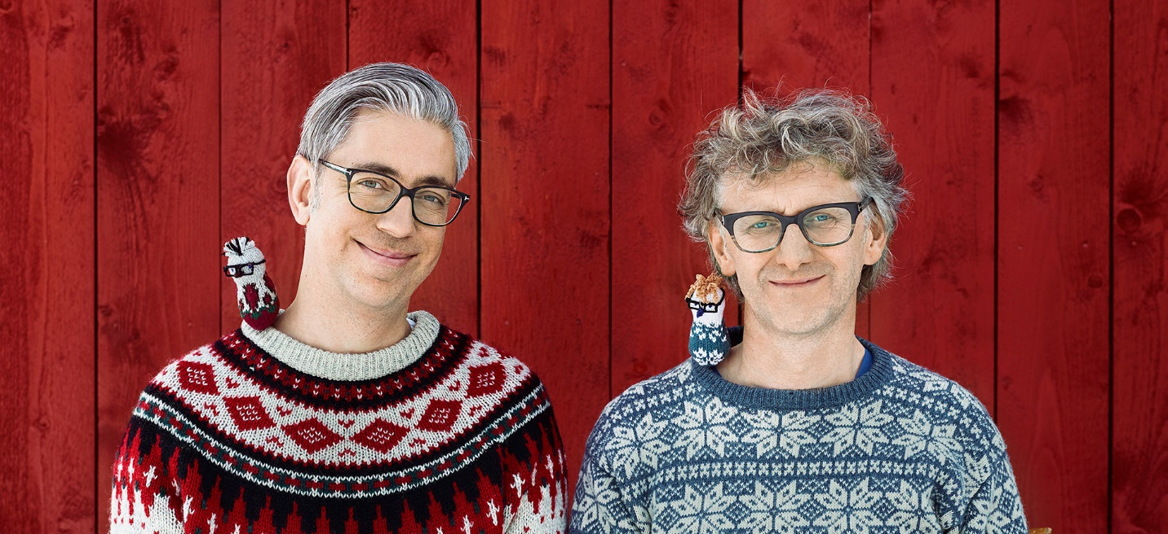
Scandinavians Arne Nerjordet and Carlos Zachrisson are highly regarded designers, textile artists and authors. They are best known for their original, colorful and visually striking designs as well as their craft books. Their work is highly influenced by their Scandinavian background and their everyday life in rural Norway. They work under their artist name ARNE & CARLOS, which they established in 2002.
In 2010, ARNE & CARLOS’ first craft book, Julekuler (55 Christmas Balls to Knit) became an immediate Norwegian best-seller and consequently went on to become a best-selling book in North America, Europe and Asia. Today, ARNE & CARLOS have published 10 books, which are enjoyed by people from all over the world. Their books are available in Norwegian as well as English, Danish, Dutch, Estonian, Finnish, French, German, Icelandic, Italian, Japanese, Korean, Russian, Spanish and Swedish.
The two Scandinavian designers have collaborated with many prestigious international brands, including Urban Outfitters (2009) and high-end Japanese fashion label Comme des Garçons (2008). Today, they design for and work closely with Rowan, Regia and Schachenmayr yarns.
ARNE & CARLOS’ creative base is located 170 kilometers north of Oslo, Norway, in the mountainous region known as Valdres.

Arne & Carlos Workshops- Monday, November 5
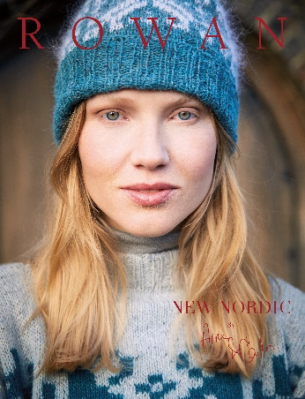
New Nordic Knitting –
An Introduction to Norwegian Stranded Colour Work
9 a.m. – 12 p.m. $75
Norwegian stranded color work is all about tension. In this class, you will learn the basics of Norwegian style stranded knitting with 2 colors from expert Nordic Knitters ARNE & CARLOS, who will show you the easiest and most relaxing way to hold the needles with multiple strands of yarn. They will teach you important techniques and trick that will help you achieve perfect tension while keeping your stitches even and beautiful, in true Norwegian style! The class will work with bulky yarn with large needles to practice color work while knitting a hat with the traditional X an O pattern. Whether you are a beginner or experienced knitter, if you have ever wanted to learn how to knit stranded color work as it is done in Nordic countries, by master knitters who come from that part of the world, this is the class for you!

Materials:
2 Skeins of ROWAN Cocoon in contrasting colors
US 8 needle 24” circular
US 10 needle 24” circular
1 set of US 10 DPNs

Homework:
With smaller circular needle CO 64 sts. Join and work in round K2, P2 ribbing for 10 rows

Important Note:
We will be focusing on stranded color work techniques, so please do not expect to finish the entire hat in the class, as the hat itself may take longer than 3 hours to complete. However, ARNE & CARLOS will give you lots of tips to take home.

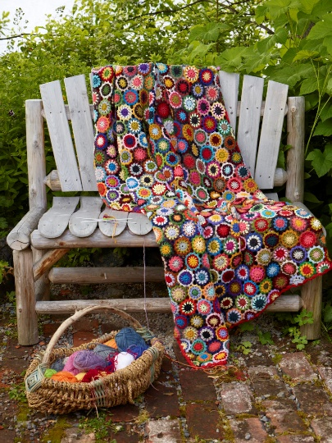
Primrose Throw for Beginning Crocheter
2 p.m. – 5 p.m. $75

Step into ARNE & CARLOS’ magical garden, one of their biggest sources of inspiration. They are obsessed with flower and the Primrose Throw was inspired by a very old piece of fabric they saw in a Norwegian mountain farm a few years ago. Primroses are a sure sign of spring. This project is for anyone with plenty of patience and time. The only “rule” is that the same two colors never meet as they are crocheted together. Use your leftover yarns and turn them into a beautiful colorful throw.

Materials:
Leftover DK weight yarn, in many colors, suitable to use with a US E-4 hook. We suggest 9 colors for this class. Yarn Suggestions: Rowan Felted Tweed, Alpaca Soft DK, Valley Tweed or other DK weight yarns
US E-4/ 3.5mm crochet hook

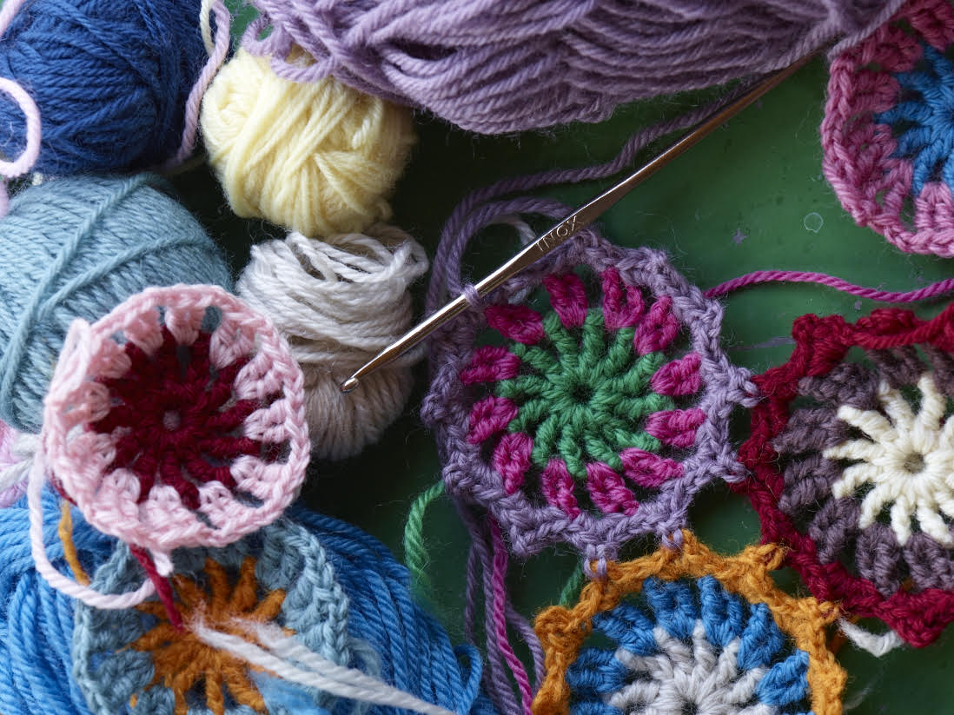

The World of Arne and Carlos Lecture – November 5, 7-9 p.m. is sold out.

